22

Web Utilities / [Subsection]
Eliminate Memory Leaks in Internet Explorer
In the past, web pages have typically used small amounts of memory. This has changed with the recent popularity of dynamic web applications, especially AJAX-enabled ones. Web pages sometimes use lots of memory while they are open. Even worse, if specific care is not taken, they will continue using that memory after the user has left the page.
A “memory leak” is a programmer term for a situation when memory has been allocated by a program, but it is never deallocated. It is not a critical programming error as it usually does not crash the program. Nevertheless it is annoying because the amount of available physical memory is limited. Using too much memory will cause the computer to run more slowly as the operating system starts swapping memory to the hard drive. In some situations, using too much memory will even cause the program to crash.
The Internet Explorer browser has a peculiarity that can cause it to leak memory. It parses the HTML document and creates a tree of document object model (DOM) objects all of which are exposed via a set of Component Object Model (COM) interfaces. Those interfaces are used to access and modify the document from JavaScript and other languages. The COM system that is built in every modern version of the Windows operating system uses reference-count garbage collection: all objects references are counted, and an object’s memory is released when its reference count reaches zero. But this does not work if there are circular references between objects. Two objects might hold references to each other and neither one of them will be garbage collected, since their reference counts will never reach zero. Native JavaScript objects such as String, Array, or user-defined objects do not rely on COM for their memory management and do not suffer from the above limitation. Crossing the COM boundary and accessing the parsed DOM objects, however, may create circular references between DOM objects or DOM objects and JavaScript objects. This can happen on your DHTML-rich page and it can degrade the performance of your web application.
Checking your application’s memory consumption and fighting leaks proactively and on a regular basis will guarantee you optimal performance and no unhappy users. Drip is an excellent tool that can help you do just that. It has been originally developed by Joel Webber and is now maintained and developed by Matthias Miller. Drip allows you to open your web application and work with it from within the program. It keeps track of DOM objects that are created and used, and displays a list of the objects that have not been freed and will keep taking up precious memory.

Tool: Drip | Version: 0.4
Homepage: http://www.outofhanwell.com/ieleak/
Power Tools Page:
Summary: Easy to use memory leak detector that keeps track of DOM objects used by Internet Explorer. The program allows you to inspect browser memory usage and detect leaking objects.
License Type: BSD
Resources: The homepage hosts a wiki that contains most of the documentation resources. The wiki has a section with references to memory leak detection and prevention articles on the web.
Related Tools: None

Requirements
Drip runs on 32-bit Windows platforms: Windows 95/98, Windows NT, Windows 2000, and Windows XP. It will work with both standalone HTML files stored on your hard drive and URL’s of live sites somewhere on the web.

Setup
No complex setup is required. Drip is a single executable file, which you can download from its homepage. The C++ source code is available too: you can compile it with Visual Studio .NET 2003 or later.

Hunting for Memory Leaks
Starting Drip will present you with the main screen as seen on Figure 22-1.
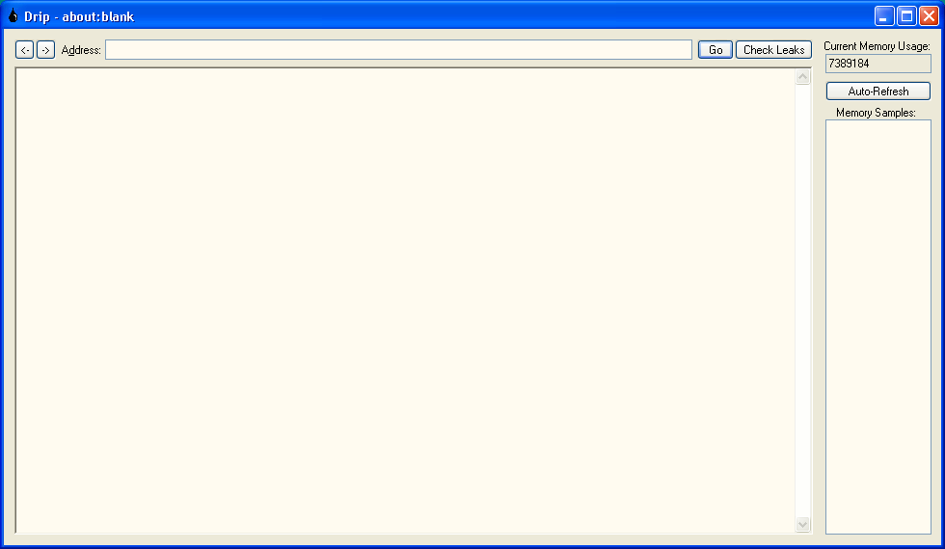
Figure 22-1. Drip main screen
Any memory leak measurement will require navigating to a web page. Type or paste the address of the page and click “Go” to load the page. The page will be loaded and will be displayed in the central browser area. The page will be fully operational and you will have to exercise any actions that will invoke the script code that you want to check for leaks. Figure 22-2 shows a sample page.
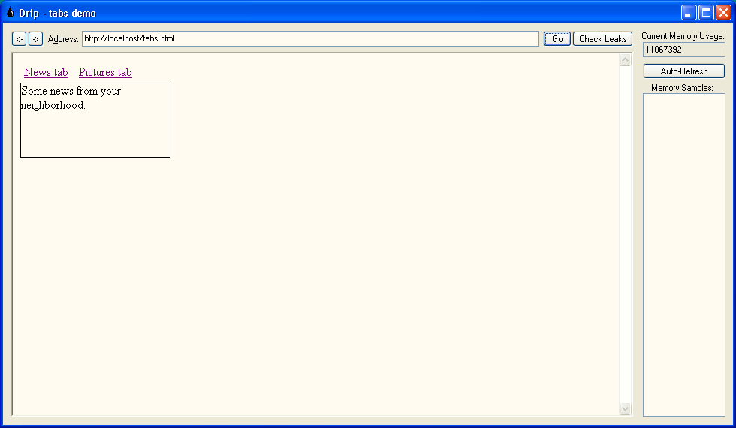
Figure 22-2. A sample page running inside Drip
Watch the memory usage field as you click around the page. The field provides additional information about memory allocations done by the browser.
Do not worry about complex sites that have several documents and pages. Drip will keep track of additional browser documents that are loaded in frames and iframes (<iframe> elements). Additionally it will detect new windows opened from the original page. The only downside is that newly opened windows cannot be automatically refreshed by the tool. Probably the best way to check documents opened in new windows is to navigate directly to their URL and check the memory usage there.

Identifying Leaked Objects
After you are done working with your page you will have to click the “Check Leaks” button. It will clear the currently loaded page, force garbage collection for unused objects, and will display a dialog with information about the leaks. The dialog will display the URL of the document that contained the object, the number of references to that object, the tag name, and the ID of the element. That information is tremendously helpful in identifying the offending elements, so that you can break the circular references and reclaim your memory. Figure 22-3 shows that our page leaks two <a> elements:
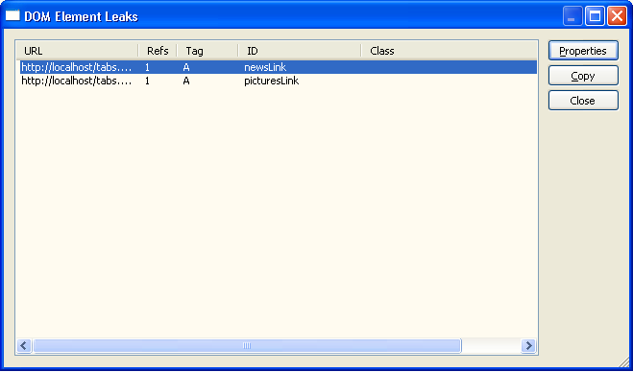
Figure 22-3. Two hyperlinks that leak memory
What if your elements do not have an ID set or you have many elements that look alike? You can get more information about a leaked element by selecting it and clicking the “Properties” button. The Properties dialog will open and it will display all the properties of that object. The best way to identify the object is to look at the innerHTML and outerHTML properties – they contain the markup that is rendered on the page and can provide important clues about the leakage.
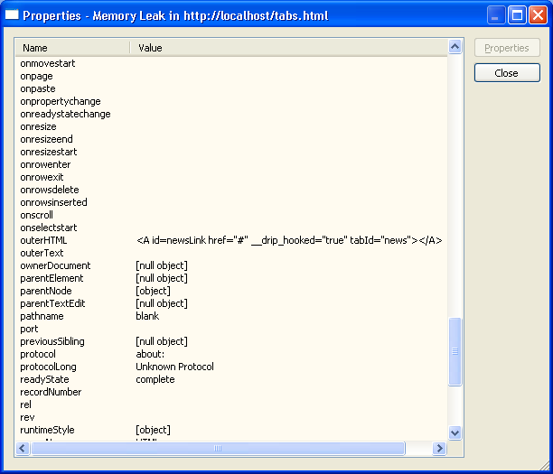
Figure 22-4. Properties like outerHTML help find unknown elements

Watching Memory Usage over Time
Probably the best way to detect problems with your application’s memory usage is to monitor the amount of memory used as repetitive tasks are performed. Drip helps in doing this with its “Auto-Refresh” feature. Clicking the button will start refreshing the page, keeping track of the memory used after each refresh. The list box on the right hand side contains the memory measurement samples. An application that leaks will take up more and more memory after each request and you can easily see that from the list. Optimized applications will keep the memory size constant with small fluctuations that might be caused by the browser’s inner workings. Figure 22-5 shows a leaky application whose memory usage grows steadily.
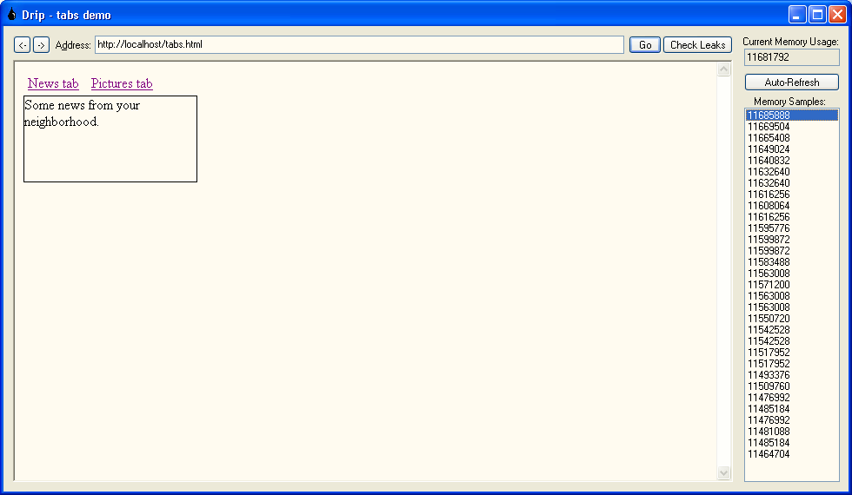
Figure 22-5. Losing approximately 7KB per request
The automatic page reloading covers the most common scenario: a web page that attaches script code to some elements’ events when the document loads. Some applications do way more than that: menus and lists are built dynamically; new form elements are created so that users can enter more data without waiting for an additional roundtrip to the server; animation effects are implemented by moving elements around the page. In order to test such complex scenarios for leaks you will either have to manually exercise them by triggering the actions or you can add a script that triggers them in the window.onload event handler for testing purposes. The code in that handler will execute every time Drip refreshes the page.

Typical Leak Scenarios and Ways to Resolve Them
The only way for an element to leak is to create a circular reference to it. The reference can be as simple as creating a new expando property that points to itself:
linkElement.circularRef = linkElement;
You can have a more complicated scenario where an object references other objects which in turn reference it back.
The most common way to create a circular reference could be the hardest to spot as there are no variables or properties declared that contain reference to objects. It usually happens when people create new functions and attach them as event handlers. Functions in JavaScript reference all the variables that are visible at the place of the function declaration. That is why they are also called closures – they encapsulate or close over the variables, so that they can be used from the function’s code, whenever it is called. Here is an example of a function that attaches two onclick event handlers to links in a tab control:
function InitializeTabs()
{
var news = document.getElementById("newsLink");
news.tabId = "news";
var pictures = document.getElementById("picturesLink");
pictures.tabId = "pictures";

function TabLinkClick()
{
var visibleTab = document.getElementById(this.tabId);
var tabContainer = document.getElementById("tabs");
var tabs = tabContainer.getElementsByTagName("div");

//hide all tabs
for (var i = 0; i < tabs.length; i++)
tabs[i].style.display = "none";

//show the selected tab
visibleTab.style.display = "block";
}

news.onclick = TabLinkClick;
pictures.onclick = TabLinkClick;
}
The TabLinkClick function is declared inside InitializeTabs. It “sees” the two variables (news and pictures) that contain references to the links in the document and encapsulates them, so that they are visible to the function code. The function is then attached as an onclick event handler to the two links. It does not matter that TabLinkClick’s code does not use news or pictures in any way – references to them are still kept by the script engine. Here lies the circular reference: each link keeps a reference to TabLinkClick as its onclick event handler and TabLinkClick keeps an internal reference to the link.
There are three possible solutions to that problem:
- Move the TabLinkClick function definition outside InitializeTabs. It will not see the link variables and will not keep references to them thus avoiding the problem altogether.
- Set news and pictures to null after you have assigned the event handlers. This breaks the references to the link variables.
- Detach the event handlers when you are done. This can be performed just before the page is unloaded in the window.onunload event handler or when the tabbed navigation is deterministically destroyed from code. Some object-oriented JavaScript libraries define a Dispose() method for each object that takes care to release all DOM object references, detach all event handlers and call the appropriate Dispose() methods of all its child objects.

Drip Limitations
Drip works by intercepting DOM element creation. Each new element is being recorded, and later checked if it has been properly released. The challenge of writing such a tool lies in intercepting the various ways a script can create new DOM elements. Drip intercepts most of them: document.createElement(…), element.cloneNode(), element.innerHTML = “<p>test</p>”, etc. The only currently known way to create elements that Drip does not intercept is setting the outerHTML property of an element. For example, you can create a new <div> element by setting an element’s outerHTML property, create a circular reference, and it will leak, going undetected. The only sound advice on dealing with that at the moment is to avoid using outerHTML altogether. Another reason to do so is that the property is not W3C standards compliant and it works in Internet Explorer only.
The recent AJAX popularity has changed the rules of the memory management game. AJAX is an acronym for Asynchronous JavaScript And XML – it is a way for a web application to initiate an HTTP request from script, retrieve data, and update only a portion of the page without having to submit the entire form contents and force the user to reload the entire document. The lower latency and increased responsiveness of this development approach has given birth to applications that users can use for hours without navigating away from a page. Google’s GMail service is an example of such an application. This style of development poses new challenges to memory management. Applications can use up more and more memory without creating circular references just by regularly requesting new content from the server and updating the current document. New DOM elements created after an AJAX request make the current document more and more complex. They may not technically leak, and the memory can be reclaimed after the page reloads, but this may not happen for quite some time. Soon the user finds herself in a situation where the browser takes up several hundred megabytes of memory for no obvious reason. Reloading the page will reclaim the memory, but the whole point of AJAX is to avoid doing that.

Summary
Currently the main resource for Drip-related news and information is the tool homepage and Matthias Miller’s weblog at http://outofhanwell.com/blog/. The homepage contains links to articles that explain the memory leak problem in greater detail and provide specific solutions and code samples. The SourceForge project page at http://sourceforge.net/projects/ieleak provides forums for support requests, feature suggestions and various community discussions.
Drip provides enormous help to web developers that create complex, JavaScript-rich websites by helping resolve memory-related problems. Leaks have been a problem with Internet Explorer for a lot of time and will continue to be a problem even with the next version of the browser – Internet Explorer 7, as it will continue to use the COM-based object model. The browser will likely remain highly popular, so fighting memory leaks will continue to be an important part of a web developer’s skill set.

